How to Edit Rosters

- Go into WCAP https://wa.portal.airast.org/
- Enter as a Test Administrator
- Click the TIDE button
- Use the dropdown next to Rosters under Preparing for Testing and select View/Edit Rosters
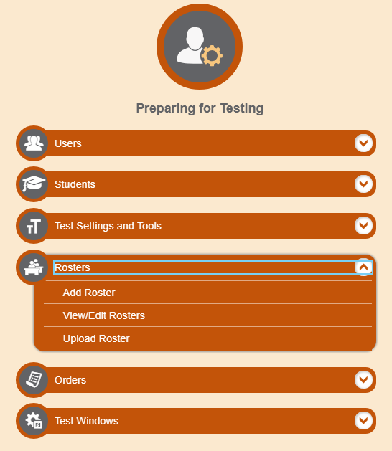
- Use the dropdown menu to select your school and click search.
- Click the pencil next to the Roster you want to edit.
- If you want to add students you can search by SSID or name or grade and hit search.
- Then select the students on the left that you want to add and click Add Selected.
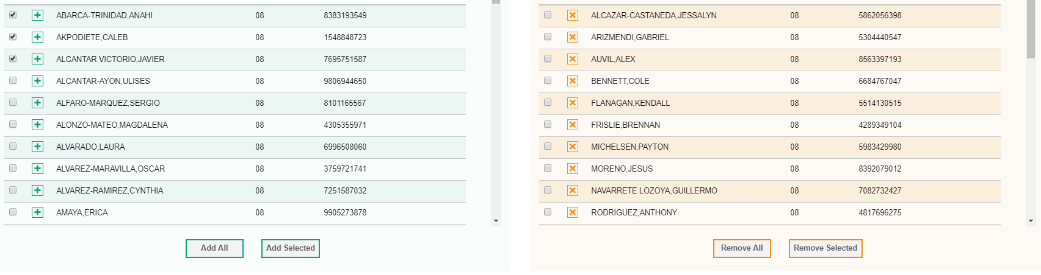
- If you want to remove students, then select the students on the right that you want to remove and click Remove Selected.
- Make sure you click Save at the bottom of the page to update your roster.

